**ASSIGNMENT NO: 01**

1. In the below elements which of them are values or an expression? eg:- values can be

integer or string and expressions will be mathematical operators.

Ans 1. Values: ‘hello’, -87.8 , 6

Expressions: * , - , / , +

2. What is the difference between string and variable?

Ans 2. String is a sequence of character which is always be in start and ends with quotes.

Eg: Variable= Hello

String: “Hello”

3. Describe three different data types.

Ans 3. There are three types of Data types in Python: Int , Float, String

Int: These are the data types which takes the values(or data ) in the form of whole numbers(+ve or -ve) but no fractional parts.

Eg: a=10, b=20

Float: These are the data types which takes data as an Real no with decimal parts in it.

Eg: a=20.0, b=3.14

String: These are the data types which take data in the form of sequence of characters enclosed insides quotes.

Eg: name=”Tom”, “Alice”.

4. What is an expression made up of? What do all expressions do?

Ans 4. Expressions are combination of operands and operators that are used to give results.

It produces some value or result after being interpreted by the Python interpreter

5. This assignment statements, like spam = 10. What is the difference between an

expression and a statement?

Ans 5. An expression is used as an operations to give results, while statement is used for creating values or displaying variables.

6. After running the following code, what does the variable bacon contain?

bacon = 22

bacon + 1

Ans 6. 

7. What should the values of the following two terms be?

‘spam' + ‘spamspam’

‘spam' * 3

Ans 7. 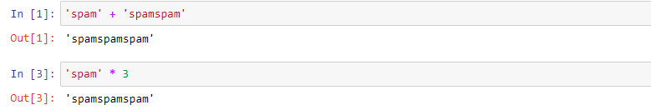

8. Why is eggs a valid variable name while 100 is invalid?

Ans 8. In python there are some rules before naming the variables:

1. Variable name can start with alphabets or underscore.

2. Variable name cannot be started with a number

So 100 is invalid as variable name is starting with number and not with alphabet or underscore.

9. What three functions can be used to get the integer, floating-point number, or string

version of a value?

Ans 9. int() to get integer

float() to get floating-point

str() to get string.

10. Why does this expression cause an error? How can you fix it?

‘I have eaten’ +99+ ‘burritos’.

Ans 10. This expession cause error because we cannot concatenate string with integer .

Correct code below:

